FINAL PROJECT

|  |  |
| --- | --- |
| Team ID | PNT2022TMID40723 |
| Project Name | Real-time river water quality monitoring and control system |

# Abstract:

Current water quality monitoring system is a manual system with a monotonous process and is very time-consuming. This paper proposes a sensor-based water quality monitoring system. The system consists of several sensors which is used to measure physical and chemical parameters of the water. The main components of Wireless Sensor Network (WSN) include a microcontroller for processing the system, communication system for inter and intra node communication and several sensors. Real-time data access can be done by using remote monitoring and Internet of Things (IoT) technology. Data collected at the apart site can be displayed in a visual format on a server PC with the help of Spark streaming analysis through Spark MLlib, Deep learning neural network models, Belief Rule Based (BRB) system and is also compared with standard values. If the acquired value is above the threshold value automated warning SMS alert will be sent to the agent. The uniqueness of our proposed paper is to obtain the water monitoring system with high frequency, high mobility, and low powered. Therefore, our proposed system will immensely help Bangladeshi populations to become conscious against contaminated water as well as to stop polluting the water.

# Introduction:

The environment around consists of five key elements e.g., soil, water, climate, natural vegetation, and landforms. Among these water is the utmost crucial element for human life. It is also vital for the persistence of other living habitats [1]. Whether it is used for drinking, domestic use, and food production or recreational purposes, safe and readily available water is the need for public health [2]. So it is highly imperative for us to maintain water quality balance. Otherwise, it would severely damage the health of the humans and at the same time affect the ecological balance among other species [3]. Water pollution is a foremost global problem which needs ongoing evaluation and adaptation of water resource directorial principle at the levels of international down to individual wells. It has been studied that water pollution is the leading cause of mortalities and diseases worldwide. The records show that more than 14,000 people die daily worldwide due to water pollution. In many developing countries, dirty or contaminated water is being used for drinking without any proper prior treatment. One of the reasons for this happening is the ignorance of public and administration and the lack of water quality monitoring system which makes serious health issues [3, 4]. In this paper, we depict the design.

# Related works:

To design a good quality model, we reviewed out different existing system developed by researchers. Different authors have proposed distinguished models to check water quality by analyzing the parameters such as temperature, pH and conductivity, and so on. By considering all these points, we designed a smart water monitoring system which can perform all these monitoring functions. Stephen Brosnan investigated a WSN to collect real time water quality parameters (WQP). Quio Tie-Zhn, developed online water quality monitoring system based on GPRS/GSM [15]. The information was sent by means of GPRS network, which helped to check remotely the WQP. Kamal Alameh presented web based WSN for monitoring water pollution using ZigBee and WiMAX networks. The system collected, processed measured data from sensors, and directed through ZigBee gateway to the web server by means of WiMAX network to monitor quality of water from large distances in real time. Dong He developed WQM system based on WSN [14]. The remote sensor was based on ZigBee network. WSN tested WQP and sent data to Internet using GPRS. With the help of Web.

# pH sensor:

The pH of thing is a useful constant to display because graduate and low pH levels can hump large effects on the author. The pH of a statement can grasp from 1 to 14. A pH sensor is an instrumentation that measures the hydrogen-ion density in a bleach, indicating its tartness or alkalinity. Its constitute varies from 0 to 14 pH.

# IoT Platform:

The quality parameters are labeled datasets including desired outputs of specific combination of inputs. The neural network will produce output to classify water quality as dangerous, be careful, and good. The classification layer will run on top of Hadoop cluster [17]. The advantages of using neural network based analytics are like Artificial Neural Networks (ANNs) are good in learning and modeling non-linear relationships, and high volatile data [18]. Though neural networks are prone to over fitting, the neural network model used in water quality monitoring system is not complex enough to cause over fitting problem. Also, there are many countermeasures to avoid over fitting. Also, computation overload is not going to delay the response of system as there are only a few water quality parameters.

# Real-time monitoring of water quality by using IoT integrated Big Data Analytics:

IoT devices use various types of sensors to collect data about turbidity, ORP, temperature, pH, conductivity, etc. of river water continuously. Also, IoT devices have capability to stream the array of collected data wirelessly to the remote Data Aggregator Server in the cloud. Moreover, the volume of semi structured data increases with time in such a velocity that only the Big Data Analytics applications can efficiently store and analyze the data constantly [18]. The system should be reliable and scalable. So, data management layer will be deployed and operational on the Apache Hadoop cluster. Hadoop helps distributed storing and processing of big data across cluster of computers. Also, such operational environment is horizontally scalable i.e. nodes or computers can be added to a cluster later while volume and velocity of data streaming will be increasing. Hadoop cluster is fault tolerant as jobs are redirected automatically to the running nodes when nodes are failed. The data in Hadoop is highly available as multiple copies of data are stored in data nodes managed by name node, standby name node, journal nodes and failover controller. IoT applications need high speed of read/write of data and highly available data. 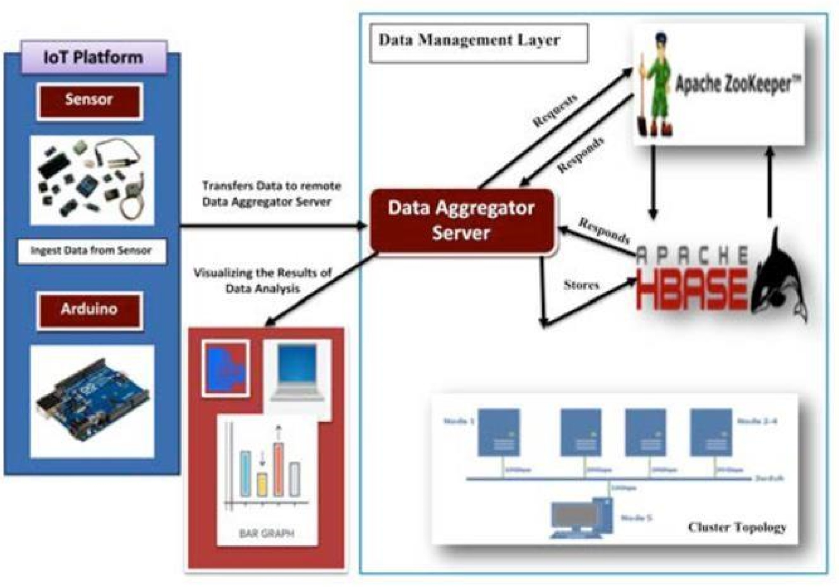

# Result:

we are displaying the resulting sensed pH, temp, turbidity, and ORP

values. It continuously senses the values of pH, temp, turbidity, and ORP and the resulting values are displayed to the LCD, PC or mobile in real-time. If the acquired value is above the threshold value comments will be displayed as ‘BAD’. If the acquired value is lower than the threshold value comments will be displayed as ‘GOOD’. A bar/line graph will also be shown for perfect understanding. The time series representation of sensor data with decision the resulting sensed pH, temp, turbidity, and ORP values. It continuously senses the values of pH, temp, turbidity, and ORP and the resulting values are displayed to the LCD, PC or mobile in real-time. If the acquired value is above thelue comments will be displayed as ‘GOOD’. A bar/line graph will also be

shown

for

perfect understanding.

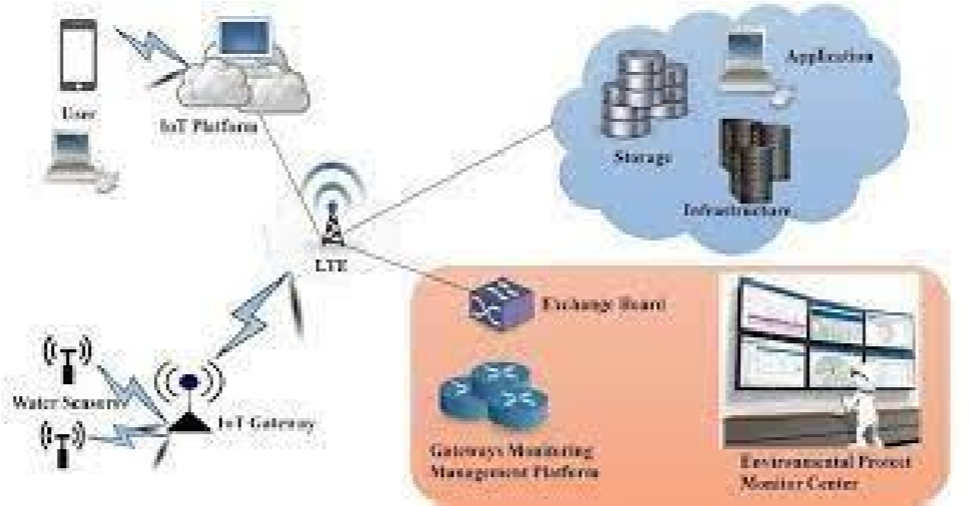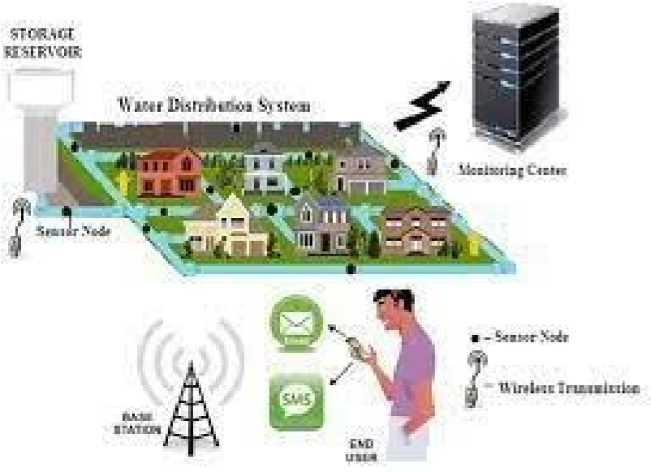

# Conclusions and future works :

Real-time monitoring of water quality by using IoT integrated Big Data Analytics will immensely help people to become conscious against using contaminated water as well as to stop polluting the water. The research is conducted focusing on monitoring river water quality in real-time. Therefore, IoT integrated big data analytics is appeared to be a better solution as reliability, scalability, speed, and persistence can be

provided. During the project development phase an intense comparative analysis of real-time analytics technologies such as Spark streaming analysis through Spark MLlib, Deep learning neural network models, and Belief Rule Based (BRB) system will be conducted [20-27]. This research would recommend conducting systematic experimentation of the proposed technologies in diverse qualities of river water in Bangladesh.